**1.Define multimedia. Write down the properties of multimedia.**

Answer :

Multimedia is a combination of text, graphics, images, video, and audio to enrich its content and enhance communication.

**Properties of a Multimedia System:**

* **Discrete and continuous media**
  + Support of one type does not constitute multimedia
* **Independent media**
  + The media used in a MM system should be independent.
* **Computer-controlled systems**
  + We need a system capable of processing media in a computer-controlled way.
* **Integration**
  + Independent media streams can be integrated to form a global system.

**2. Define Multimedia System. What are desirable features of multimedia system? Write down some applications of multimedia systems.**

Answer :

Multimedia System : Multimedia system is a system capable of processing multimedia data and applications.

**Desirable Features for a Multimedia System:**

**Very High Processing Power** — needed to deal with large data processing and real time delivery of media.

Special hardware commonplace.

**Multimedia Capable File System** —needed to deliver real-time

media — e.g. Video/Audio Streaming.

**Special Hardware/Software needed** – e.g. RAID technology.

**Data Representations** — File Formats that support multimedia

should be easy to handle yet allow for

**compression/decompression** in **real-time**.

**Efficient and High I/O** —input and output to the file subsystem

needs to be efficient and fast. Needs to allow for real-time

recording as well as playback of data.

e.g. Direct to Disk recording systems.

**Special Operating System** —to allow access to file system and

process data efficiently and quickly. Needs to support direct

transfers to disk, real-time scheduling, fast interrupt

processing, I/O streaming etc.

**Storage and Memory** — large storage units (of the order of

hundreds of Tb if not more) and large memory (several Gb

or more). Large Caches also required and high speed buses

for efficient management.

**Network Support** — Client-server systems common as

distributed systems common.

**Software Tools** — user friendly tools needed to handle media,

design and develop applications, deliver media.

**Some applications of multimedia system:**

1. World Wide Web
2. Hypermedia courseware
3. Video conferencing
4. Video-on-demand
5. Interactive TV
6. Groupware
7. Home shopping
8. Games
9. Virtual reality
10. Digital video editing and production systems.

**3.Define multimedia presentation. What are the characteristics of multimedia presentation?**

Answer:

**Multimedia Presentation**: A multimedia presentation is a message that uses multimedia.

**Characteristics of multimedia presentation:**

**Multiple media**:Multimedia presentation comprises of text, graphics and images, animation, sound, and video.

**Integrity:** Although there may be several media types present and playback simultaneously, they need to be integrated or be part of a single entity which is the presentation.

**Digital representation:** Multimedia requires instant access to different portions of the presentation. This is best done inside a digital computer which store data on random access devices like hard disk, and compact disc. Multimedia presentations are produced and played back on the digital platform.

**Scope of interactivity:** To make non-linearity a possibility, a user needs to interact with a presentation. For non-linear presentation, a user can directly navigate to an area of interest. Such interaction is made possible through a set of interactivity elements embedded within the presentation like buttons, menu items or hyperlinks.

**Non-linearity:** Non-linearity is the capability of navigating from one point within a presentation to another point without appreciable delay.

*4.Define multimedia production? What are the hardware and software requirements of a multimedia production?*

**Multimedia production:** Multimedia production is any sort of production that uses imagery and a combination of text, audio, and graphics to tell a story.

**Software and hardware requirements in multimedia production are listed below:**

**Processors and memory:**

The processors should be at least of the Pentium II or higher. RAM should be at least of 128 MB.

**Disk:**

A huge amount of disk space, typically 10GB is required.

**Monitor and video adapter:**

Monitor and video adapter should confirm to SVGA standards and should be able to support 800 X 600 display mode with true color.

VRAM should be at least 4MB.

**CD-ROM drive and CD-writer:**

The pc should be equipped with a CD-ROM drive having a speed of at least 4X.

The pc should have a CD-Writer, because most of the multimedia presentation are delivered on CD-ROM disk.

**Sound cards, speaker and microphones:**

The pc should have a sound card and attached a sound speaker.

**System software:**

It should be compatible with windows 95 or higher with standard software for playback of media files in standard format.

*5. What do you mean by multimedia authoring? What are the functions of the authoring tools? Write some names of authoring tools.*

Multimedia authoring involves collating, structuring and presenting information in the form of a digital multimedia, which can incorporate text, audio, and still and moving images.

**Functions of authoring tools are listed in below:**

1. It provides the framework for organizing and editing the elements of multimedia projects.
2. It enables the developer to combine text, graphics, videos and animation an interactive presentation.

**Some names of authoring tools are listed in below:**

1. Articulate
2. Captivate
3. Composica
4. Lectora
5. KnowledgePresenter.

**6.What is bitmapped font and Outline font? What is the difference between bitmapped and Outline font?**

**Bitmapped font**: A bitmapped font is a font with jagged edges when enlarged, instead of a scalable font where no matter what the size, it looks the same.

**Outline font/Vector font:** A font that defines the outline of each character is by mathematical values. This font can be scaled to any size without any loss of clarity. A good example of an outline font is TrueType.

**Difference between Bitmapped and Outline are given in the below:**

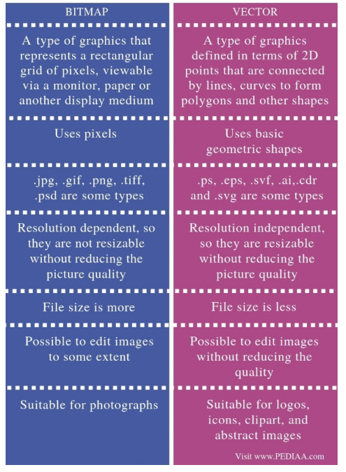

**7.Briefly discuss the Postscript font and True Type font.**

**Postscript font:**

PostScript has traditionally been preferred by professional designers, publishers and printers because of its reliability and the wider selection of fonts available in this format. PostScript has a clever rasterizing engine, and font hinting (screen optimization) is less important than in TrueType, since it is taken care of at the system level.

PostScript fonts consist of two parts, a bitmapped screen file, which displays the font on the computer monitor, and a printer file defining the outline curves.

PostScript fonts, which can access only 220 characters, are not compatible with Unicode, and are not compatible across platforms. Examples : Futura (T1) Bold, Futura (T1) Book.

**TrueType font:**

A TrueType font is a font standard and is the major type of font found in both Mac and Microsoft Windows operating systems. It consists of a single binary file which contains a number of tables related to printer and screen versions of the typeface. Developed by Apple and Microsoft, it gave font developers the much needed flexibility for control of the precise characteristics for font display.

Examples : Futura(TT) Condensed Medium, Futura (TT) Medium Italic.

**8.What do you mean by typeface and font? What is the difference between Serif and Sans Serif font?**

**Typeface:** The graphic representations of the alphabet, numbers and special character.

**Font:** A font is the combination of typeface and other qualities, such as size, pitch, and spacing. For example, Times Roman is a typeface that defines the shape of each character.

**Difference between Serif and Sans Serif font:**

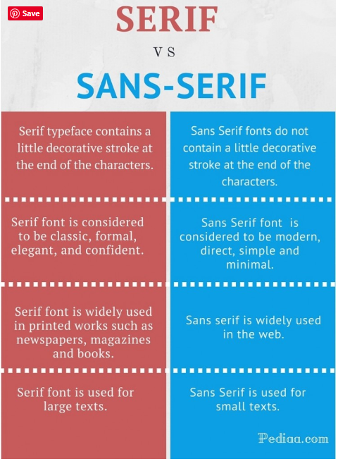

***9.Define Jaggies and Antialiasing. How Jaggies be removed?***

**Jaggies:** The technique is used to blend the font into the background by transitioning the colour from the font colour to background.

**Antialiasing:** This technique minimizes the jagged edges making for a smoother overall appearance.

The effect of jaggies can be removed somewhat by a graphics technique known as spatial anti-aliasing.

***10.Which type of font has Jaggies? Explain why it occurs?***

**Bitmap font is jagges.**

**11.What do you know about sampling and quantization of audio signal? Explain with example.**

Show the video : <https://www.youtube.com/watch?v=W5q-Ac0JVdk>

**12.Briefly describe digitalization process of audio signal.**

Show the video : <https://www.youtube.com/watch?v=iW6e7tQ6WUk>

**13.Write the importance and drawbacks of digital representation of the analog signal.**

**Importance of digital representation of analog signal:**

Because of their digital nature they can travel faster in over digital lines.

Ability to transfer more data as compared to analog.

We store analog signal in electronic storage in the form of digital form.

**Drawbacks of digital representation of the analog signal:**

We lost some data.

Greater bandwidth is essential.

Systems and processing is more complex.

**14. Define SQNR. Calculate the SQNR of N bit quantization.**

**SQNR:** SQNR, short for signal to quantization noise ratio, is a measure of the quality of the quantization, or digital conversion of an analog signal. Defined as normalized signal power divided by normalized quantization noise power.

For a quantization accuracy of N bits per sample, the SQNR can be simply expressed:

SQNR = 20log10 = 20log10 = 20 * N * log2 = 6.02N(dB).

*15.State Nyquist theorem. Define Nyquist rate, Nyquist frequency and alias frequency with example.*

**Nyquist theorem:** According to the Nyquist theorem, the sampling rate must be at least 2 times the highest frequency contained in the signal.

such that, fs >= 2fc, fs = sampling frequency, fc = highest frequency contained in the signal.

**Nyquist rate:** Sampling rate must be at least two times the bandwidth, the highest frequency in the signal to avoid aliasing, this is known as the Nyquist rate.

**Nyquist frequency:** Sampling frequency must be at least two times the bandwidth, the highest frequency in the signal to avoid aliasing, this is known as the Nyquist frequency.

Example: A signal with highest frequency 200HZ, then Nyquist frequency must be 400HZ or higher.

**Alias frequency:** Aliased frequency is the absolute difference between the actual signal frequency and the nearest integer multiple of the sampling frequency.

*16.What is nonlinear quantization? Why nonlinear quantization is needed for audio signal digitalization?*

**Nonlinear quantization:** Nonlinear quantization is a quantization process in which step size is not constant.

**17.What do you mean by MIDI? Distinguish between digital audio and MIDI music.**

**MIDI:**  A protocol that enables computer, synthesizers, keyboards, and other musical device to communicate with each other.

**Difference between digital audio and MIDI music are listed below:**

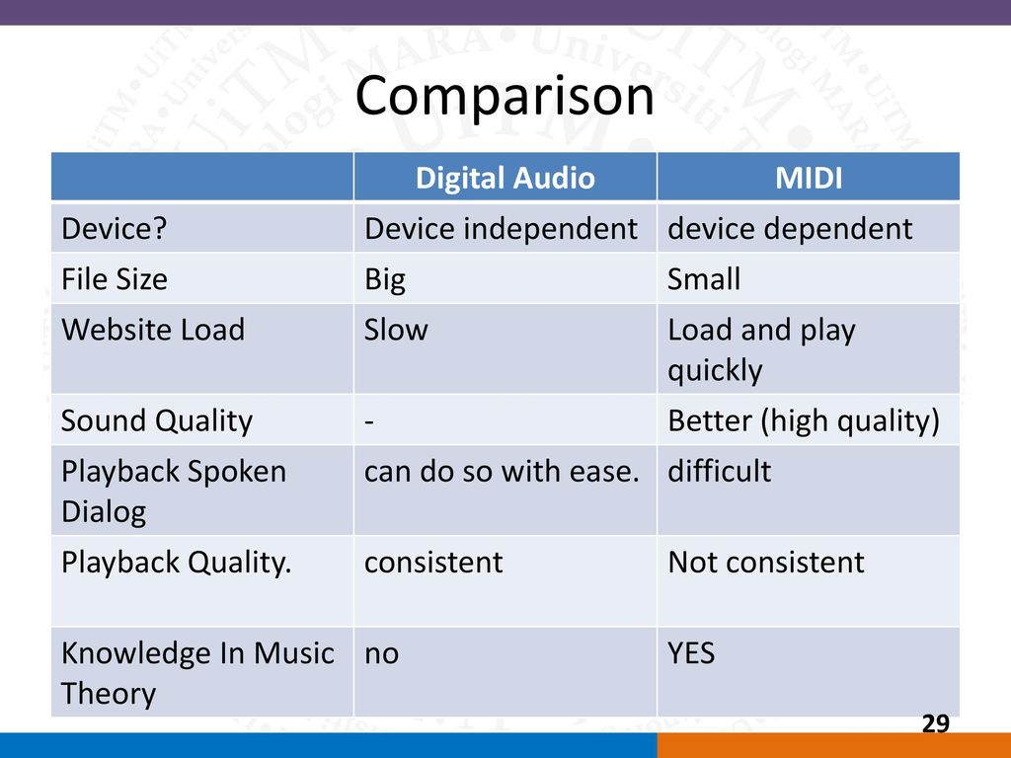

**18.What is digital audio? What are advantages digital audio over MIDI?**

Digital audio refers to a digital representation of the audio waveform for processing, storage or transmission. When analog sound waves are stored in digital form, each digital audio file can be decomposed into a series of samples.

**Advantages:**

Lower cost.

Represent actual sound.

Emulate voice and other effects.

Easy to edit.

**19.What do you mean by MIDI message? Discuss different types of MIDI message.**

**MIDI Message:** A MIDI message is made up of an eight-bit status byte which is generally followed by one or two data bytes. There are a number of different types of MIDI messages. At the highest level, MIDI messages are classified as being either Channel Messages or System Messages.

**There are two types of MIDI message and these are:**

1. Channel message
2. System message

**Channel message:** can have up to 3 bytes:

The first byte is the status byte (the opcode, as it were); has its most significant bit set to 1.

The 4 low-order bits identify which channel this message belongs to (for 16 possible channels).

The 3 remaining bits hold the message. For a data byte, the most significant bit is set to 0.

Channel message divided into two another categories:

1. Voice message
2. Channel mode message

**Voice message:**

This type of channel message controls a voice, i.e., sends information specifying which note to play or to turn off, and encodes key pressure.

Voice messages are also used to specify controller effects such as sustain, vibrato, tremolo, and the pitch wheel.

**Channel mode message**:

Channel mode messages: special case of the Control Change message → opcode B (the message is &HBn, or 1011nnnn).

However, a Channel Mode message has its first data byte in 121 through 127 (&H79–7F).

Channel mode messages determine how an instrument processes MIDI voice messages: respond to all messages, respond just to the correct channel, don't respond at all, or go over to local control of the instrument.

**System message:**

System messages have no channel number — commands that are not channel specific, such as timing signals for synchronization, positioning information in pre-recorded MIDI sequences, and detailed setup information for the destination device.

Opcodes for all system messages start with & HF.

System messages are divided into three classifications, according to their use:

1. System common messages

2. System real-time messages

3. System exclusive messages

**System common messages:** relate to timing or positioning.

**System real-time messages:** related to synchronization.

**System exclusive message:** included so that the MIDI standard can be extended by manufacturers.

**20. An analog signal containing components with frequency values ranging from 50Hz to 5kHz is to be sampled. Determine the sampling frequency and the bandwidth of the band limiting filter. If the signal is transmitted over a communication channel with a bandwidth from 100Hz to 4.5kHz, determine the sampling frequency and the bandwidth of the band limiting filter.**

**Answer:**

As per the Nyquist theorem, sampling rate must be at least twice the bandwidth or the highest frequency components of the source signal.

Hence the sampling rate = 2 * 5kHz = 10kHz

The bandwidth of the band limiting filter is from 0Hz to 5kHz.

In this case since the bandwidth of the transmission of the channel is smaller than that of the source signal, so sampling rate = 2 * 4.5kHz = 9kHz

The bandwidth of the band limiting filter is from 0Hz to 4.5kHz.

**21. An audio signal is digitalized at a sampling rate of 44.1kHz, a bit depth of 16 and in stereo mode. Calculate the space occupied by 10 minute of the audio and its data rate for playback.**

Answer:

Here sampling rate = 44.1kHz = 44,100 Hz

Duration/time is 60 * 10 = 600 seconds

Resolution is 16 bits

Number of channels for stereo is 2

So, Space required = (44100 * 600 * 16 * 2) / 8 = 105840000 bytes.

And data rate = 44100 * 16 * 2= 1411200 bytes / s

**22.An audio signal is recorded on a computer in stereo mode using a bit depth of B such that its data rate is R KB/sec. Find an expression for the average frequency of the signal.**

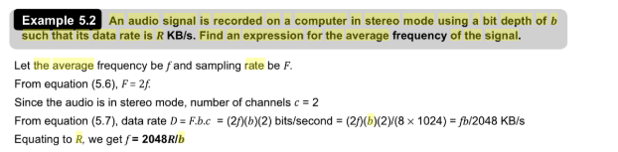

23.

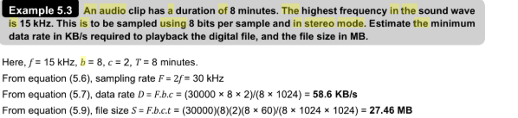

**24.Define color LUT. Briefly discuss the process to make a 8 bit color LUT out of 24 bit color.**

**LUT**: A Look-Up Table (LUT) is mathematically precise way of taking specific RGB image values form a source image – and modifying them to new RGB values by changing the hue, saturation and brightness values of that source image.

**Process to make a 8 bit color LUT out of 24 bit color:**

**Simple method:**

humans are more sensitive to R and G than to B

• 3-bit range 0…7 for Red and Green channels

• 2-bit range 0…3 for Blue channel

Divide the R or G byte value by 32 (256/8) and then truncate

**Median Cut algorithm:**

**Step 1:** Create a "cube" of the colors in the pixels of an image by

using each color component (R, G, and B) as an axis (e.g. x, y, z).

**Step 2:** Calculate the range of each color component (R, G, B).

**Step 3:** For the component with the largest range, calculate the

median value, M.

**Step 4:** Split the "cube" of colors according to the median. If the number of cubes is equal

to our chosen number of desired colors, exit the loop.

**Step 5:** For each color cube, calculate the range of each component, choose the cube which contains the largest range, and repeat.

**Step 6:** For each cube, averaging the colors in each box.

*25.What is the difference between 24 bit color image and 8 bit color image?*

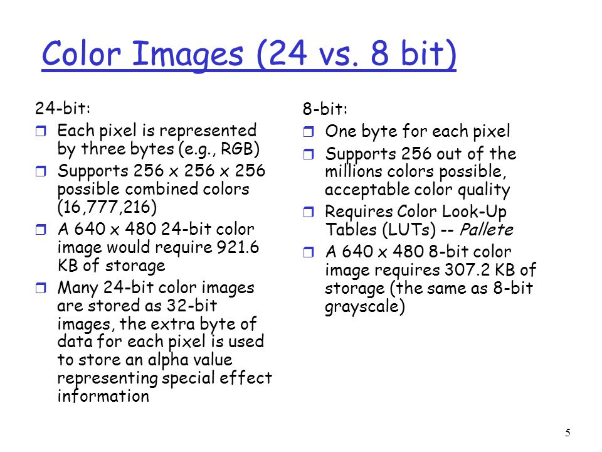

**26. What is dithering? When dithering is needed? Briefly discuss.**

**Dithering:** Dithering is the most common means of reducing the color range of images down to the 256 (or fewer) colors seen in 8-bit GIF images. Dithering is the process of juxtaposing pixels of two colors to create the illusion that a third color is present.

**Needed of Dithering:**

Dithering is used to calculate patterns of dots such that values from 0 to 255 correspond to patterns that are more and more filled at darker pixel values, for printing on a 1-bit printer.

The main strategy is to replace a pixel value by a larger pattern, say 2×2 or 4×4, such that the number of printed dots approximates the varying sized disks of ink used in analog, in halftone printing (e.g., for newspaper photos).

Half-tone printing is an analog process that uses smaller or larger filled circles of black ink to represent shading, for newspaper printing.

If we use an n × n matrix of on-off 1-bit dots, we can represent n2+1 levels of intensity resolution.

Three dots filled in any way counts as one intensity level.

For example, if we use a 2×2 dither matrix

*27. Define vector image and raster image. Difference between raster image and vector image.*

**Vector image:** Vector images are computer graphics images that are defined in terms of 2D points, which are connected by lines and curves to form polygons and other shapes.

**Raster image:** A raster image is an image file format that is defined by a pixel that has one or more numbers associated with it. The number defines the location, size, or color of the pixels. Raster images are commonly .BMP, .GIF, .JPEG, .PNG, and .TIFF files.

**Difference between raster image and vector image:**

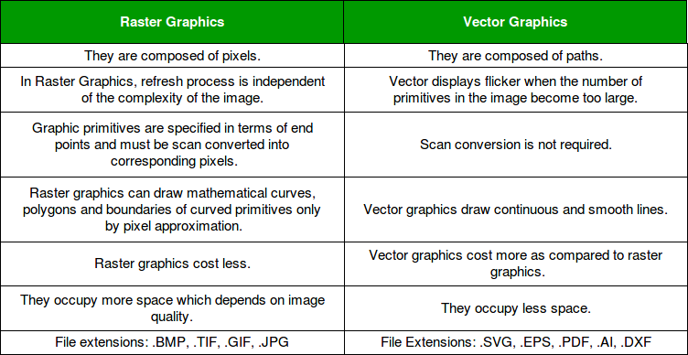

**28.Write short note about the following image format: JPEG, GIF, PNG, WMF, TIFF.**

**JPEG (Joint Photographic Expert Group):** The most important current standard for image compression.

The human vision system has some specific limitations and JPEG takes advantage of these to achieve high rates of compression.

JPEG allows the user to set a desired level of quality, or compression ratio (input divided by output).

**GIF (Graphics Interchange Format):** Limited to 8-bit (256) color images only, which, while producing acceptable color images, is best suited for images with few distinctive colors (e.g., graphics or drawing).

GIF standard supports interlacing - successive display of pixels in widely-spaced rows by a 4-pass display process.

GIF actually comes in two flavors:

1. GIF87a: The original specification.

2. GIF89a: The later version. Supports simple animation via a Graphics Control Extension block in the data, provides simple control over delay time, a transparency index, etc.

**PNG:** Standing for Portable Network Graphics: meant to supersede the GIF standard, and extends it in important ways.

Special features of PNG files include:

1. Support for up to 48 bits of color information - a large increase.

2. Files may contain gamma-correction information for correct display of color images, as well as alpha-channel information for such uses as control of transparency.

3. The display progressively displays pixels in a 2-dimensional fashion by showing a few pixels at a time over seven passes through each 8*8 block of an image.

**WMF:** Windows Metafile (WMF) is an image file format originally designed for Microsoft Windows in the 1990s. The original Windows Metafile format was not device-independent (though could be made more so with placement headers) and may contain both vector graphics and bitmap components. It acts in a similar manner to SVG files. WMF files were later superseded by Enhanced Metafiles (EMF files) which did provide for device-independence. EMF files were then themselves enhanced via EMF+ files.

**TIFF:** Tagged Image File Format, abbreviated TIFF or TIF, is a computer file format for storing raster graphics images, popular among graphic artists, the publishing industry and photographers. TIFF is widely supported by scanning, faxing, word processing, optical character recognition, image manipulation, desktop publishing, and page-layout applications. The format was created by Aldus Corporation for use in desktop publishing.

29. 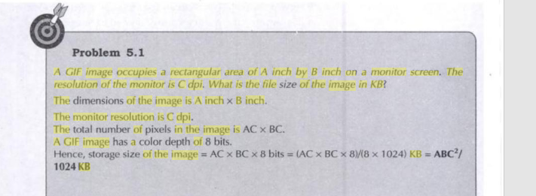

30.

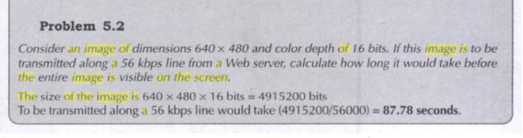

**31. Define digital video. What are the advantages of digital representation of video?**

**Digital video:** Digital video is an electronic representation of moving visual images in the form of encoded digital data. This is in contrast to analog video, which represents moving visual images with analog signals.

**Advantages of digital representation of video:**

1. **Superior image quality**
2. Easy, future-proof integration
3. Scalability and flexibility
4. Cost-effectiveness
5. Distributed intelligence
6. Remote accessibility.

**32. Define frame rate and refresh rate.**

**Frame rate**: Frame rate is the number of frames or images that are projected or displayed per second.

**Refresh rate:** A refresh rate is the number of times your monitor updates with new images each second.

**33. Define luminance(Y) and chrominance(C) of a color signal. Explain the problems in transmitting color signal.**

**Chrominance(C):**

Chrominance (*chroma*) is the signal used in video systems to convey the color information of the picture, separately from the accompanying luma signal (or Y).

**Luminance(Y):**

RGB can be converted to a luminance (brightness signal) and two color difference signals (chrominance) for TV signal transmission.

**Problems in transmitting color signal:**

The problem is accentuated by the need to fit this color signal into a standard TV channel which is almost fully occupied by the ‘Y’ signal. However, to satisfy compatibility requirements the problem has been ingeniously solved by combining the color information into a single variable and by employing what is known as frequency interleaving.

**34.** **Describe the process to generate the Y and C signal from the RGB signal from a video camera.**

Not found(*)

**35. Explain the problems in transmitting color signal.**

**Problems in transmitting color signal:**

The problem is accentuated by the need to fit this color signal into a standard TV channel which is almost fully occupied by the ‘Y’ signal. However, to satisfy compatibility requirements the problem has been ingeniously solved by combining the color information into a single variable and by employing what is known as frequency interleaving.

**36. Briefly discuss about Chroma sub-sampling on video signal transmission.**

**Chroma sub-sampling:**

Since human see color with much less spatial resolution than black and white, it makes sense to decimate the chrominance signal.

Here label numbers are given stating how many pixel values, per four original pixels, are actually sent.

Chroma subsampling scheme “4:4:4” indicates that no chroma subsampling is used.

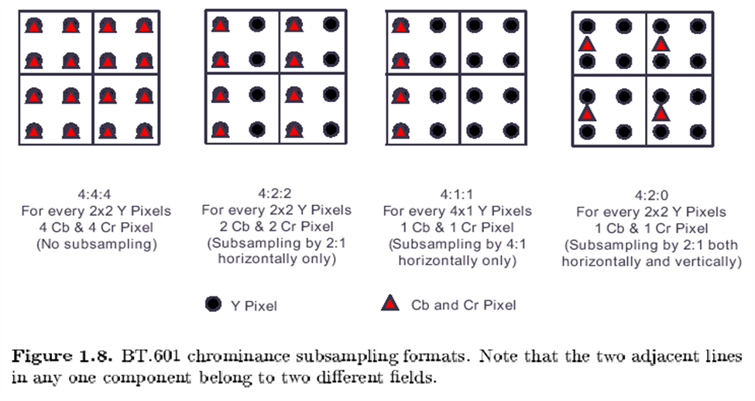

**37.Discuss the video formats Component video, Composite video and S-video.**

**Component video**: Component video is a video signal that has been split into two or more component channels. In popular use, it refers to a type of component analog video (CAV) information that is transmitted or stored as three separate signals. Component video can be contrasted with composite video (NTSC, PAL or SECAM) in which all the video information is combined into a single line level signal that is used in analog television. Like composite, component-video cables do not carry audio and are often paired with audio cables.

**S-Video:** S-Video (also known as separate video and Y/C) is a signaling standard for standard definition video, typically 480i or 576i. By separating the black-and-white and coloring signals, it achieves better image quality than composite video, but has lower color resolution than component video.

**Composite video:** Composite video adapts the format of an analog picture signal which is then combined with sound signals and subsequently modulated through an R F Carrier. It is a composite signal from three different sources called the Y, U and V, which are combined with sync pulses. Y represents luminance; U and V carry the hue and saturation, which together constitutes the chrominance. So, U and V together carry the information on the color signals. Composite video is also often called the CVBS, which is an abbreviation for Color, Video, Blank and Sync.

**38.** **Consider a TV camera where the maximum intensity of a color signal is represented by 1 volt. An unsaturated magenta signal is formed by mixing 70% R, 20% G and 60% B. What is the luminance output voltage for the signal? What would this value if the magenta color is saturated.**

Maximum output value of a color signal is assumed to be 1 volt. For unsaturated magenta, R = 0.7 volt, G = 0.2 volt, B = 0.6 volt. Hence Y = 0.3(0.7) + 0.59(0.2) + 0.11(0.6) =0.394 volt Since 0.5 volt represents a middle gray shade, the unsaturated magenta color would be represented by a dark gray shade (39.4% gray) Saturated magenta consists of 100% red and 100% blue, i.e., R = 1 volt, B = 1 volt. Hence, Y = 0.3(1) + 0.1(1) =0.4 volt (40% gray)

39. 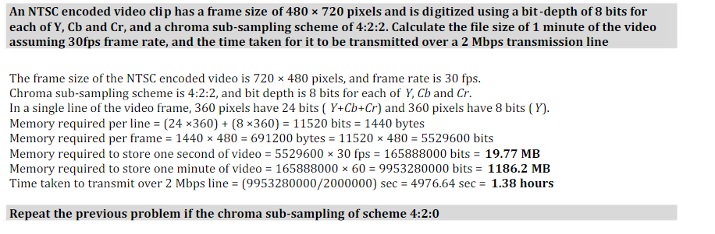

**40. What do you mean by data compression and data compression ratio? Describe the importance of data compression in multimedia system.**

**Data Compression:** The process of coding that will effectively reduce the total number of bits needed to represent data.

**Data compression ratio:** Data compression ratio, also known as compression power, is a measurement of the relative reduction in size of data representation produced by a data compression algorithm. It is typically expressed as the division of uncompressed size by compressed size.

**Importance of data compression in multimedia system:**

Data compression aims to reduce the amount of data required to represent a given quantity of information while preserving as much information as possible.

**41.What do you mean by coding?**

**Coding:** Coding is a process used in compression technique to reduce the number of bits.

**42.Describe lossless predictive coding scheme.**

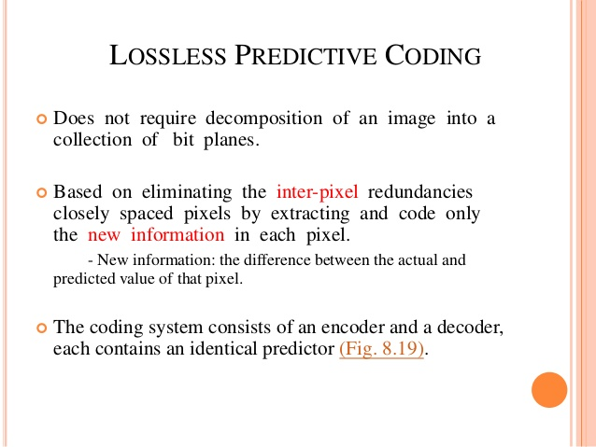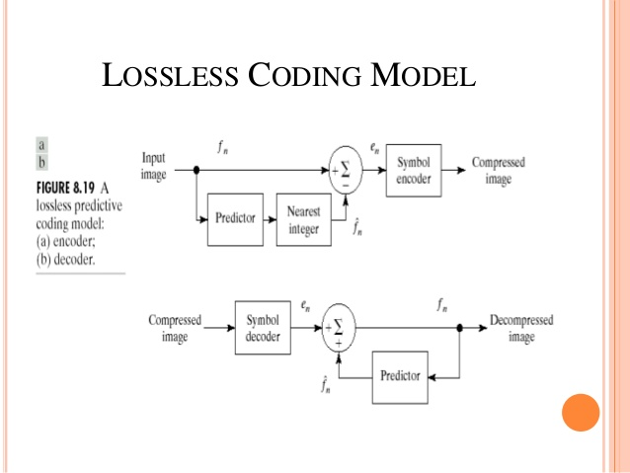

**43. Briefly discuss the DPCM coding scheme.**

Differential Pulse Code Modulation is exactly the same as Predictive Coding, Predictive coding except that it incorporates a quantizer step. Quantization is as in PCM and can be uniform or nonuniform. We should adopt some nomenclature for signal values. We shall call the original signal fn, the predicted signal fˆn, and the quantized, reconstructed signal f˜n. How DPCM operates is to form the prediction, form an error en by subtracting the prediction from the actual signal, then quantize the error to a quantized version, ˜en. The equations that describe DPCM are as follows:

fˆn = function of ( f˜n−1, f˜n−2, f˜n−3, . . .)

en = fn − fˆn

˜en = Q[en]

transmit codeword( ˜en)

reconstruct: f˜n = fˆn + e˜n

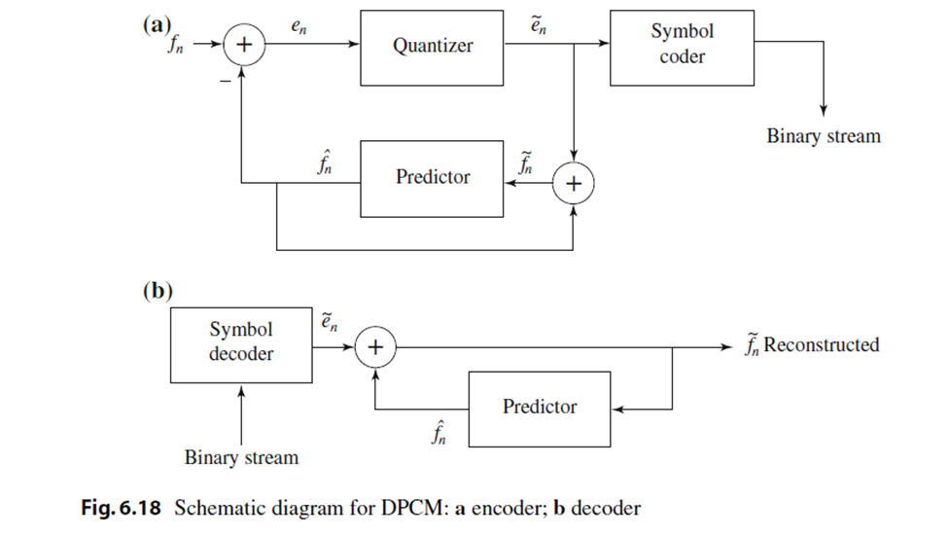

44. 

We define the entropy of an information source with alphabet S = {s1, s2, …, sn} as

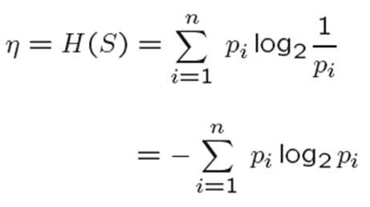

pi - probability that si occurs in the source and log21/pi is amount of information in si

45. 

Run-length coding is a very widely used and simple compression technique which does not assume a memoryless source

We replace runs of symbols (possibly of length one) with pairs of (run-length, symbol)

For images, the maximum run-length is the size of a row

Used to reduce the size of a repeating string of characters (i.e., runs)

a a a b b b b b b c c 🡪 (a,3) (b,6) (c,2)

Encodes a run of symbols into two bytes, a count and a symbol.

Can compress any type of data but cannot achieve high compression ratios compared to other compression methods.

Code each contiguous group of 0’s and 1’s, encountered in a left to right scan of a row, by its length.

1 1 1 1 1 0 0 0 0 0 0 1 🡪 (1,5) (0,6) (1,1)

46. 

**1. Initialization:** Put all symbols on a list sorted according to their frequency counts.

2. Repeat until the list has only one symbol left:

1. From the list pick two symbols with the lowest frequency counts. Form a Huffman subtree that has these two symbols as child nodes and create a parent node.

b. Assign the sum of the children's frequency counts to the parent and insert it into the list such that the order is maintained.

c. Delete the children from the list.

3. Assign a codeword for each leaf based on the path from the root.

47. 

A string with different characters, say “**ACCEBFFFFAAXXBLKE**”

Code for different characters:

Data: K, Frequency: 1, Code: 0000

Data: L, Frequency: 1, Code: 0001

Data: E, Frequency: 2, Code: 001

Data: F, Frequency: 4, Code: 01

Data: B, Frequency: 2, Code: 100

Data: C, Frequency: 2, Code: 101

Data: X, Frequency: 2, Code: 110

Data: A, Frequency: 3, Code: 111

In the above example we see that huffman coding has following properties:

No Huffman code is the prefix of any other Huffman codes so decoding is unambiguous

The Huffman coding technique is optimal (but we must know the probabilities of each symbol for this to be true)

Symbols that occur more frequently have shorter Huffman codes.

48.

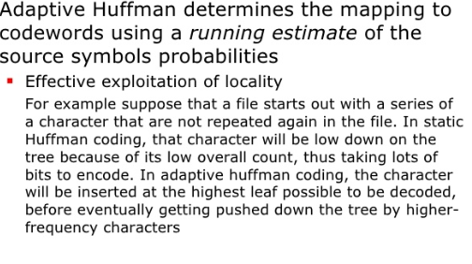

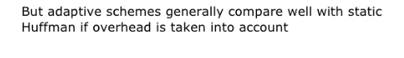

49. 

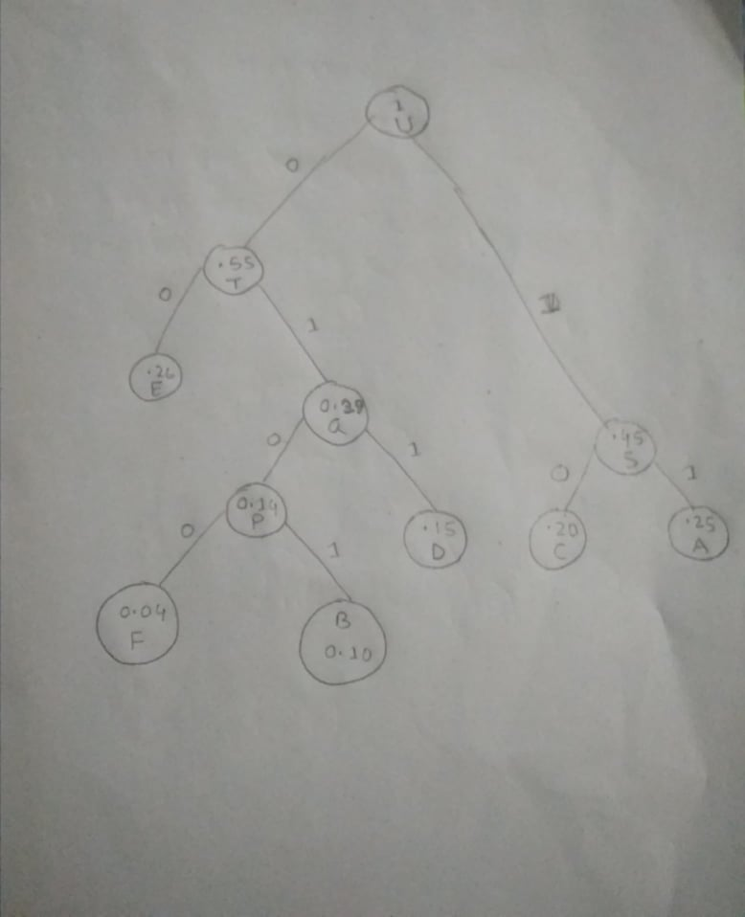

**Coding table:**

|  |  |
| --- | --- |
| Symbol | Code |
| A | 11 |
| B | 0101 |
| C | 10 |
| D | 011 |
| E | 00 |
| F | 0100 |

50. 

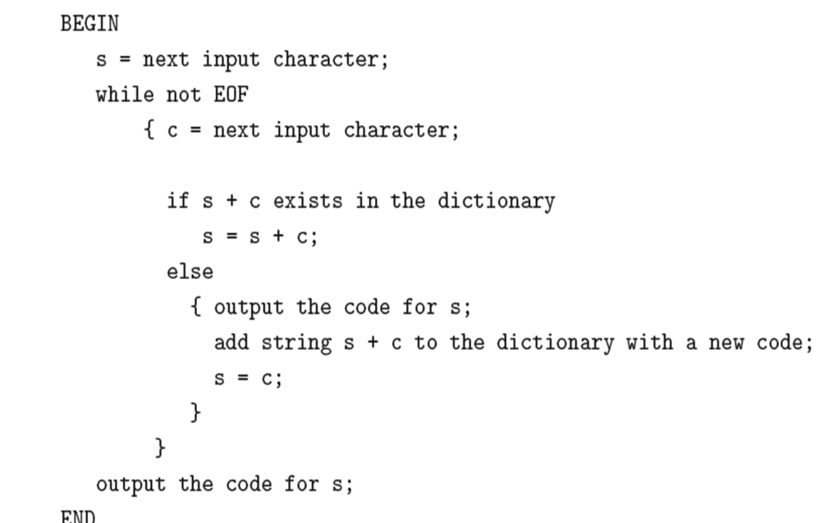

We will compress the string

"ABABBABCABABBA"

Initially the dictionary is the following

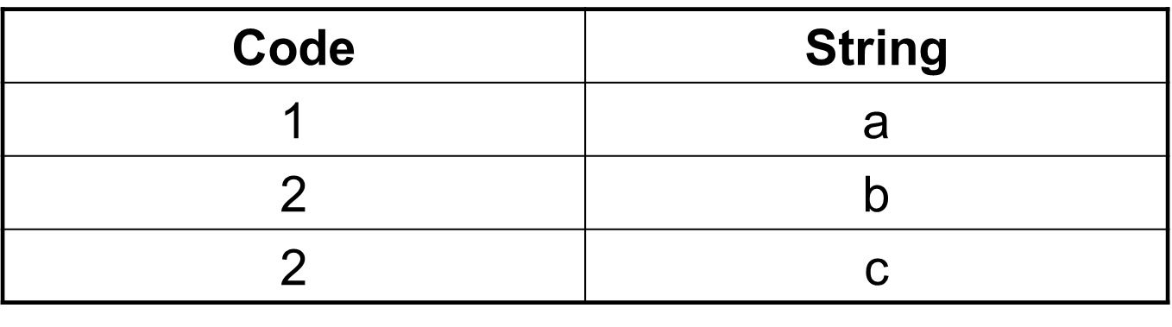

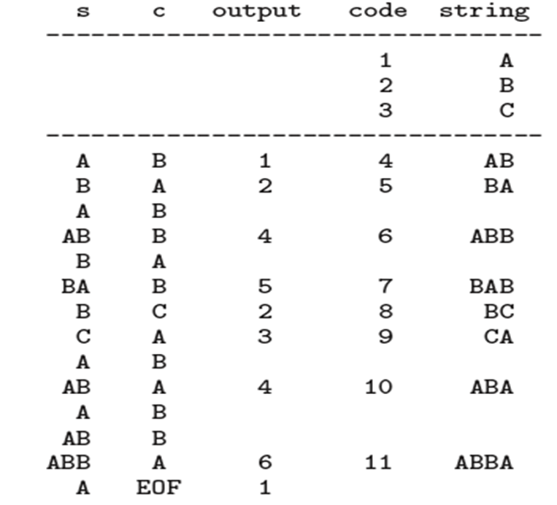

51.

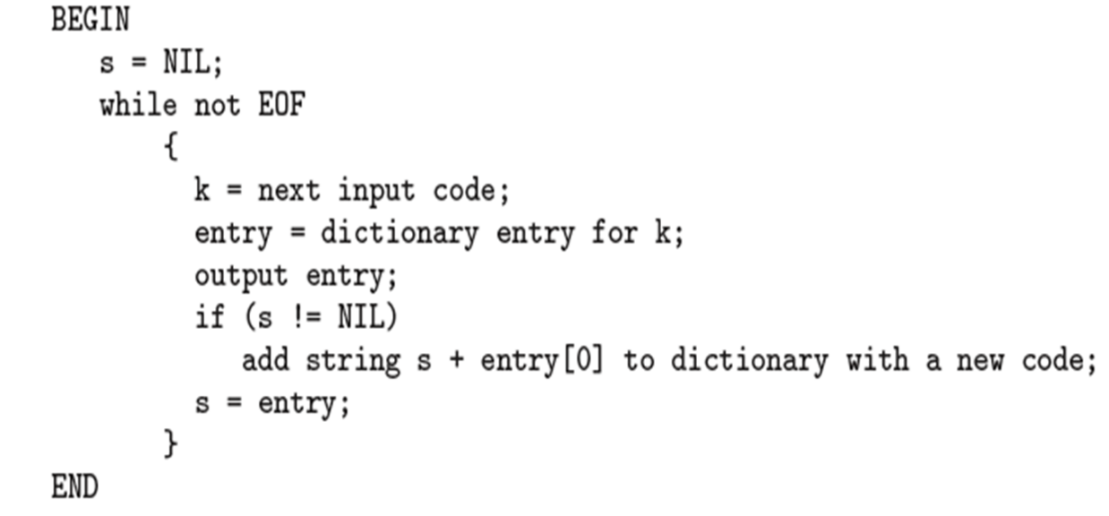

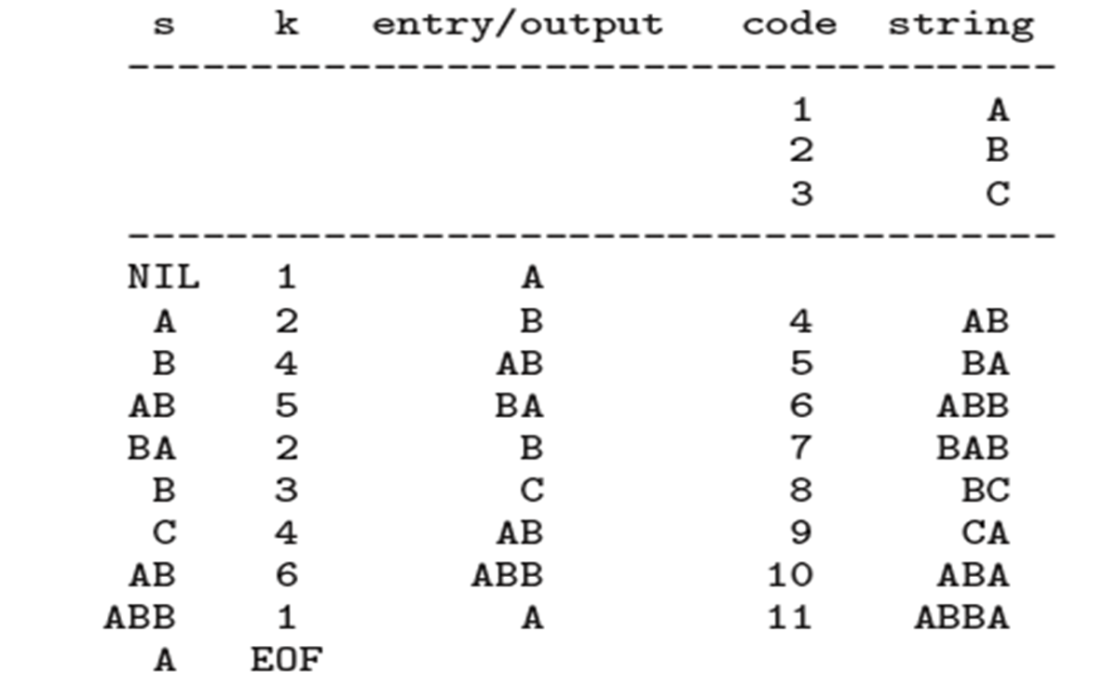

52. 

Input string : “CSERURUCSE”

|  |  |  |
| --- | --- | --- |
| Encode and output | index | entry |
| - | 1 | C |
| - | 2 | S |
| - | 3 | E |
| - | 4 | R |
| - | 5 | U |
| 1 | 6 | CS |
| 2 | 7 | SE |
| 3 | 8 | ER |
| 4 | 9 | RU |
| 5 | 10 | UR |
| 9 | 11 | RUC |
| 6 | 12 | CSE |

OUTPUT CODE : “1234596”

**Limitations of LZW Compression:**

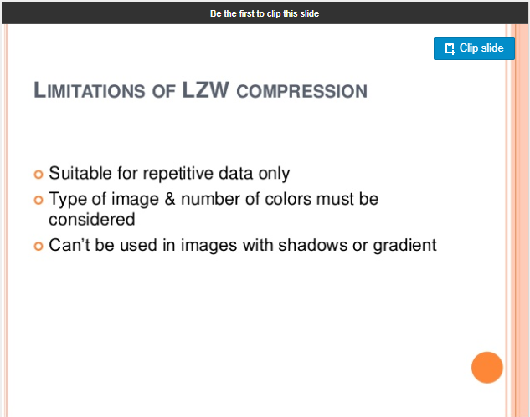

53. 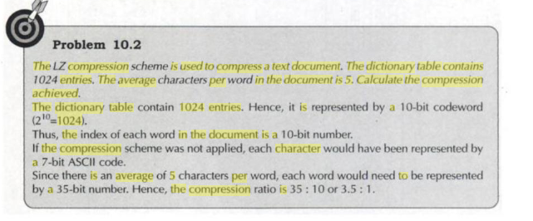

54. 

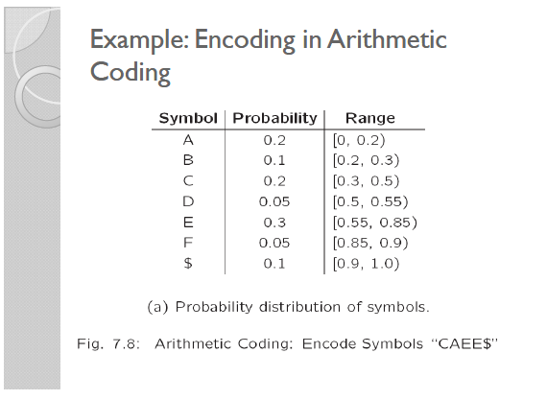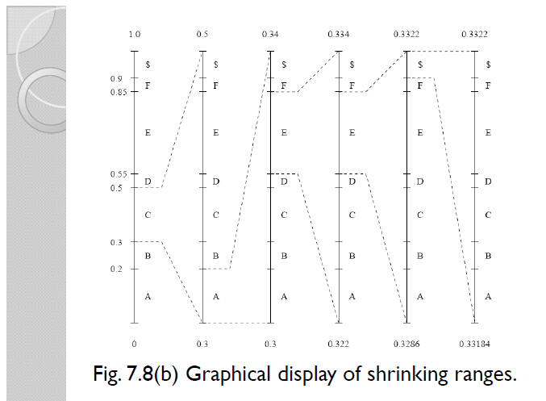

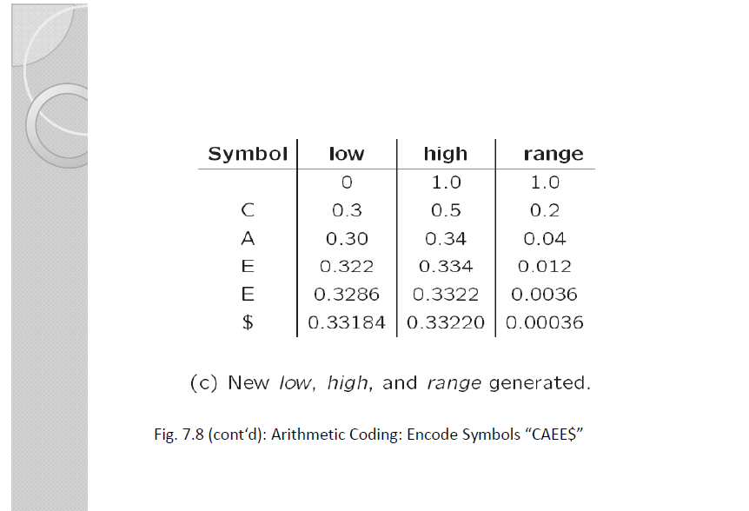

55. 

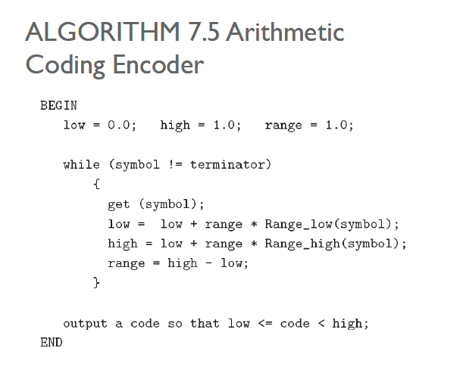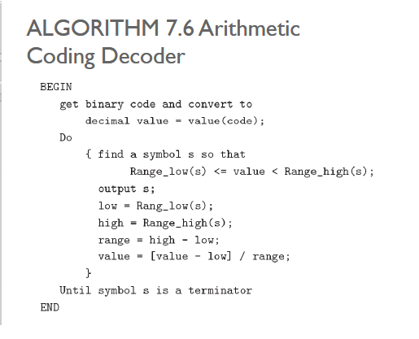

56. 

Not found.

57. 

**Lossy Compression:** Lossy compression is a method of data compression in which the size of the file is reduced by eliminating data in the file.

58. 

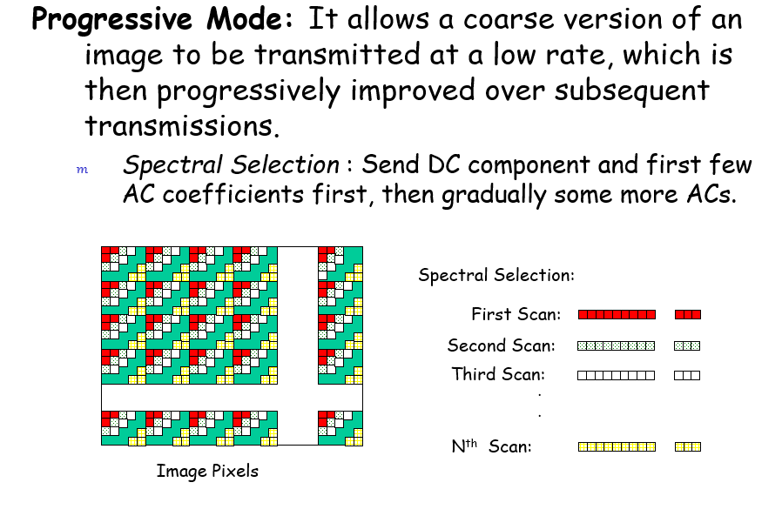

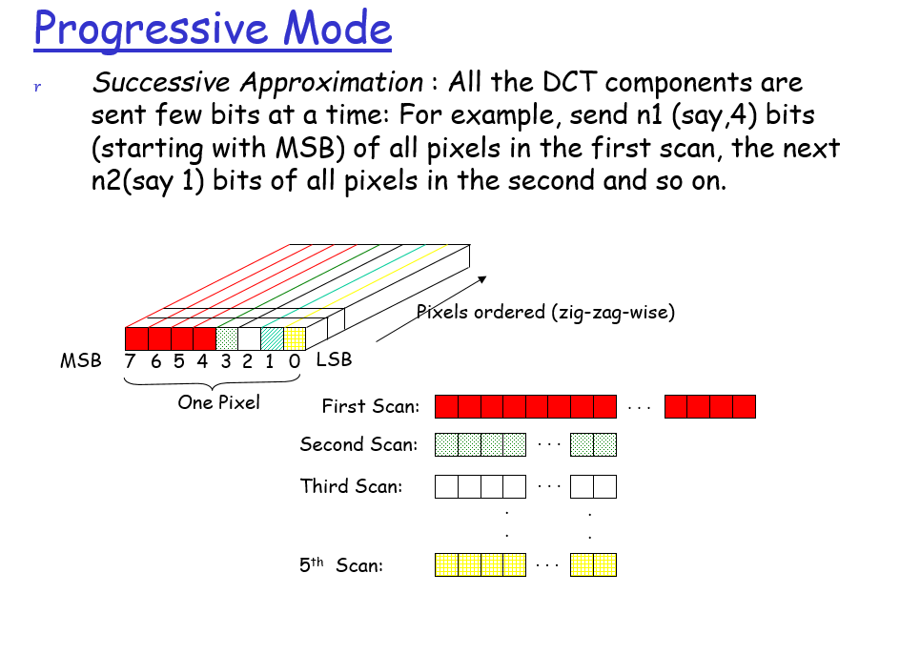

**59.** 

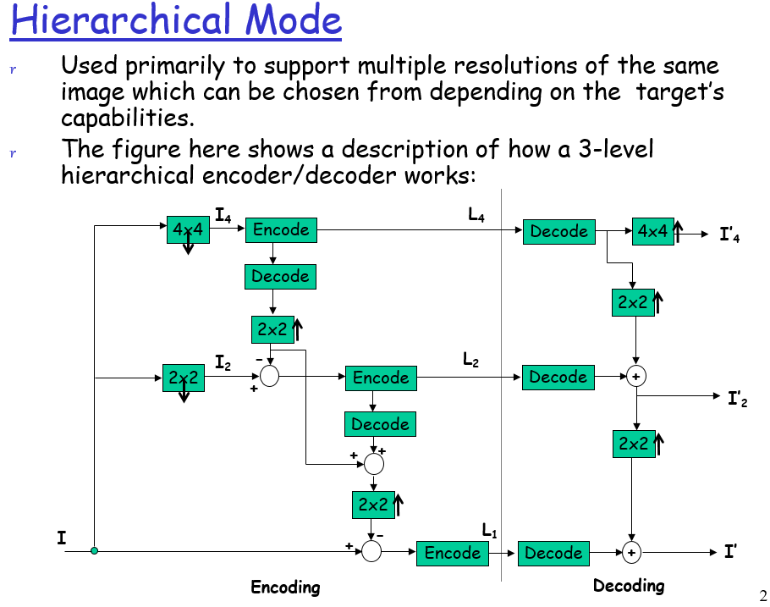

60.Define 2D DCT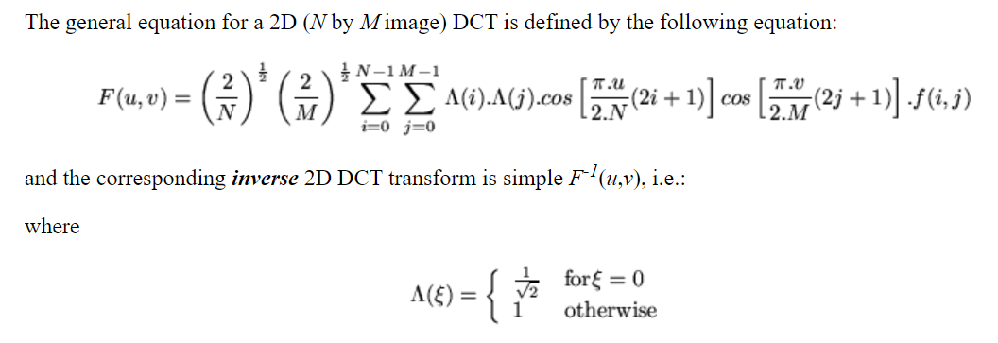

61.Write the properties of DCT

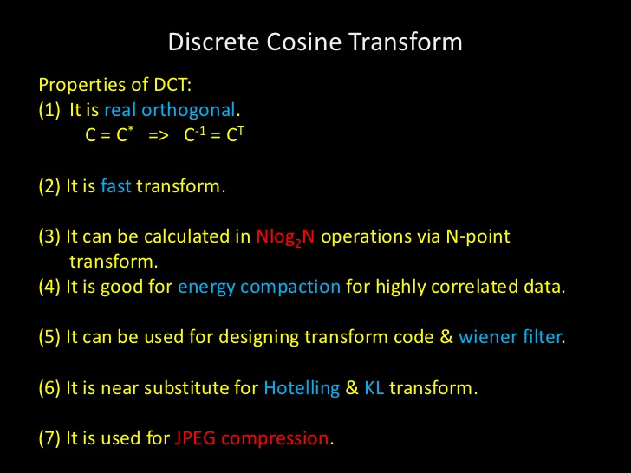

62.Which type of frames are used in MPEG video? Discuss about them.

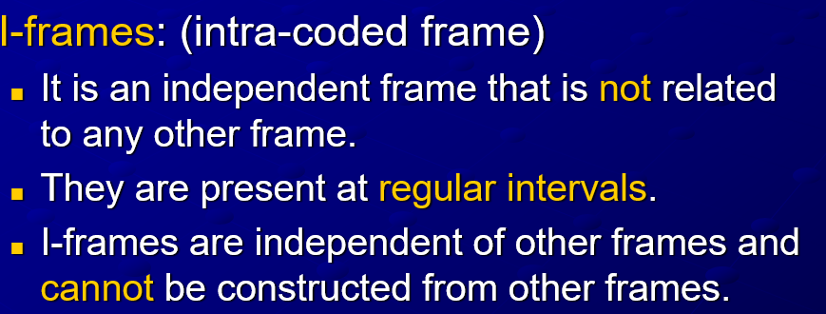

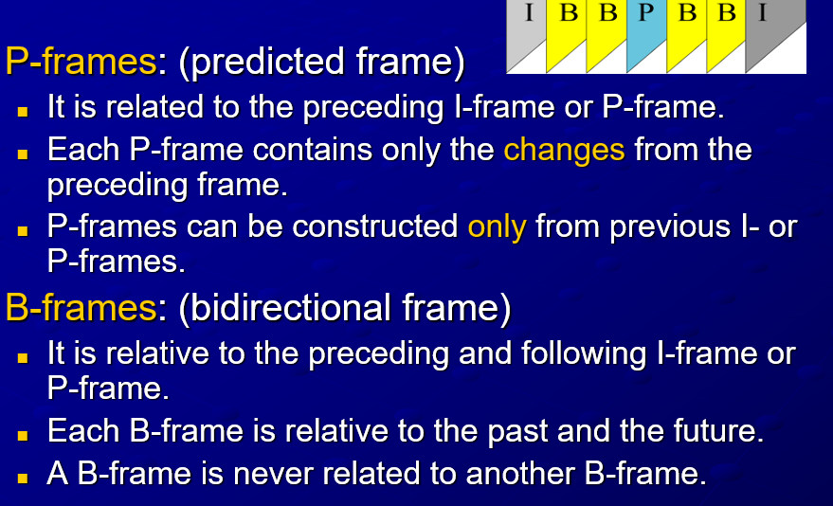

63. What do you mean by spatial and temporal redundancy?

Spatial redundancy means the correlation among neighbouring pixels in each frame of image. This can be dealt with by the techniques for compressing still images (Chapter 10). Temporal redundancy means the similarity among neighbouring frames, since a video frame tends to be similar to its immediate neighbours.